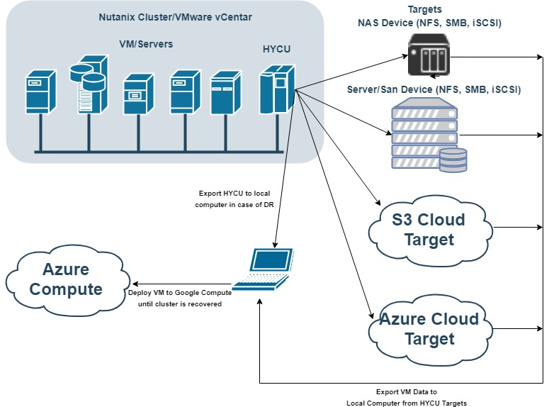
DR Recovery Scenario for Azure cloud
Prerequisites:
- Working Windows Physical Machine
- vmPlayer available for download on https://www.vmware.com/products/workstation-player/workstation-player-evaluation.html
- Installed and configured QEMU package for converting Virtual HDD files, Download QEMU From https://www.qemu.org/
- Backup of HYCU controller (exported Virtual HDD files)
NOTE: use CTRL+ left mouse click on video links to open video
IMPORTANT: Watch for uppercase and lowercase letters in command

PREREQUISITE STEP 1 (Get and Install QEMU) video file
- Get QEMU from https://www.qemu.org/
- Install QEMU to local computer (run installer, select all and just go next until finish)
- Add QEMU Install folder to Environment Variables in sections path
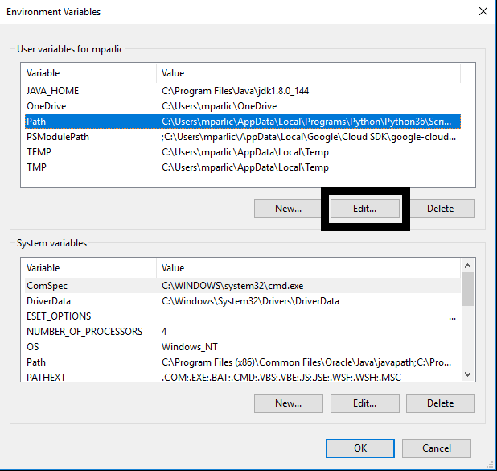
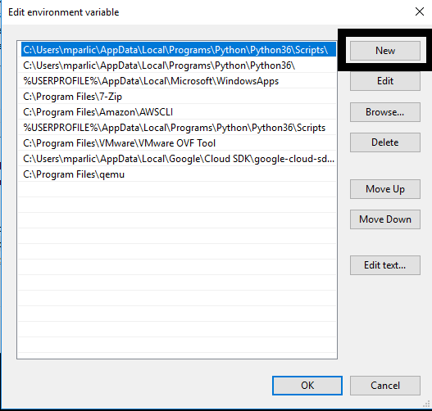
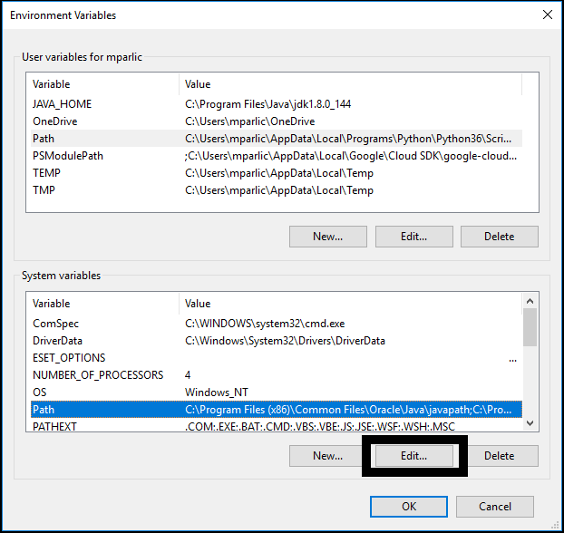
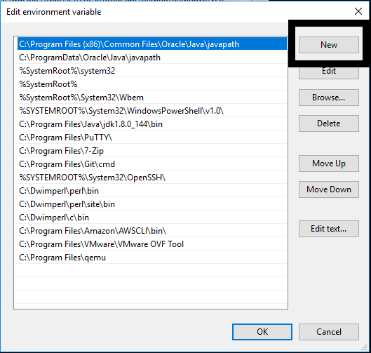

PREREQUISITE STEP 2 (Get VM Disk files of old HYCU Controller) video file
- Go to target where you have backup of HYCU controller
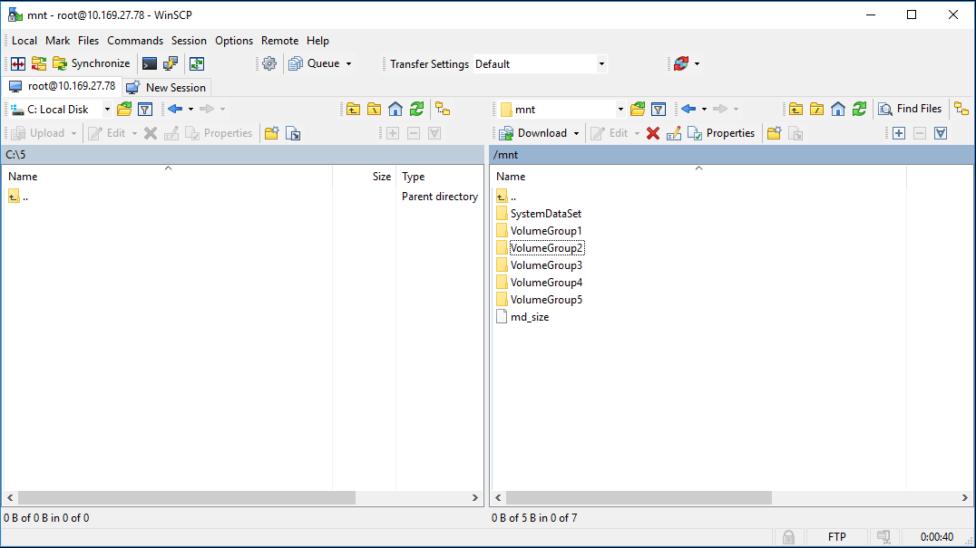
- Navigate to bkpctl directory
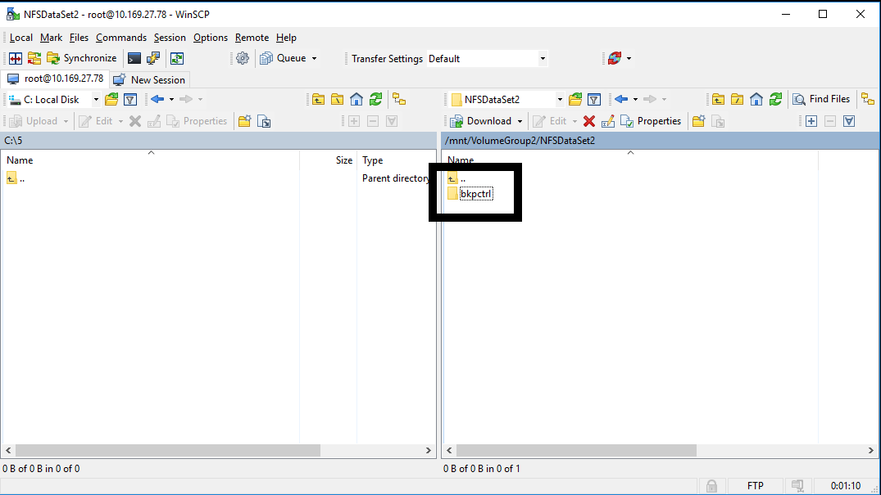
- Enter to directory that have name of UUID of previous HYCU controller
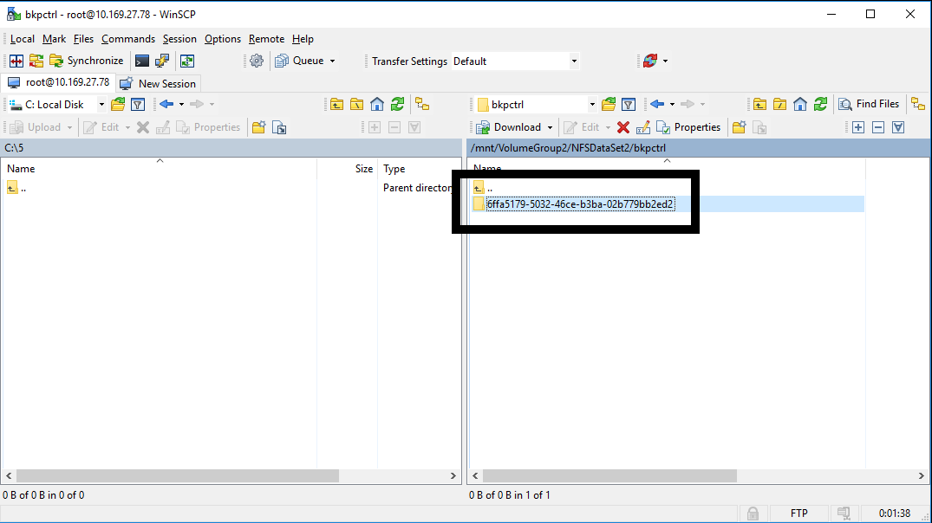

- Navigate to internal_backup_<source UUID>
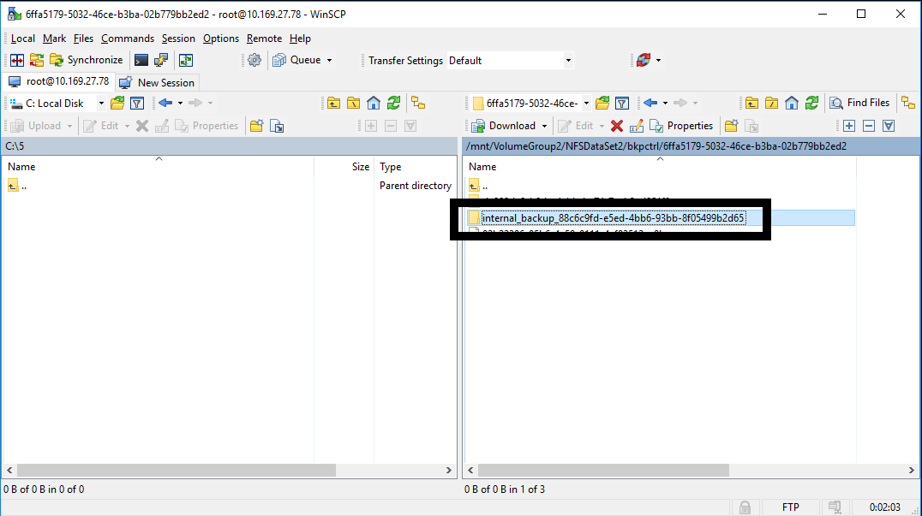
- Copy raw disk image files of HYCU controller to local computer (Virtual HDD files has crm files with same name, you only need files without extension
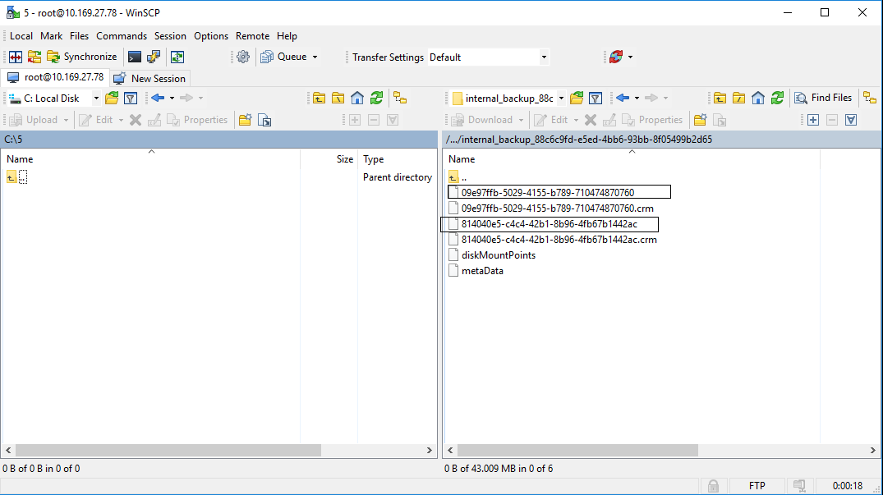
- Convert raw files to VMDK with QEMU tool (smaller file is boot disk, and should be first disk of VM)
command that need to be used is qemu-img convert –f raw –O vmdk <name of raw image file> <name of vmdk>.vmdk
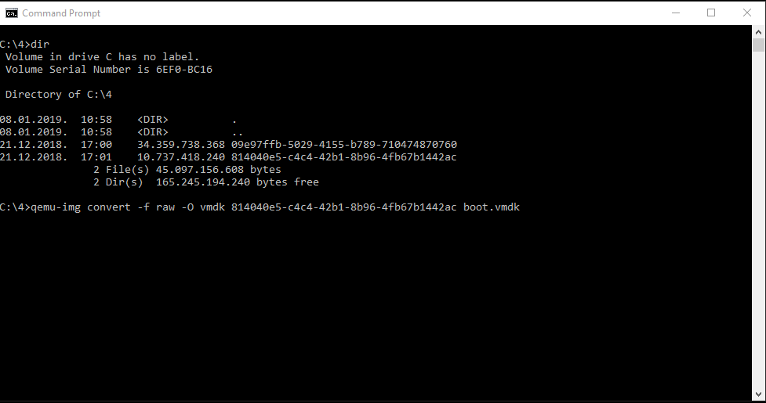
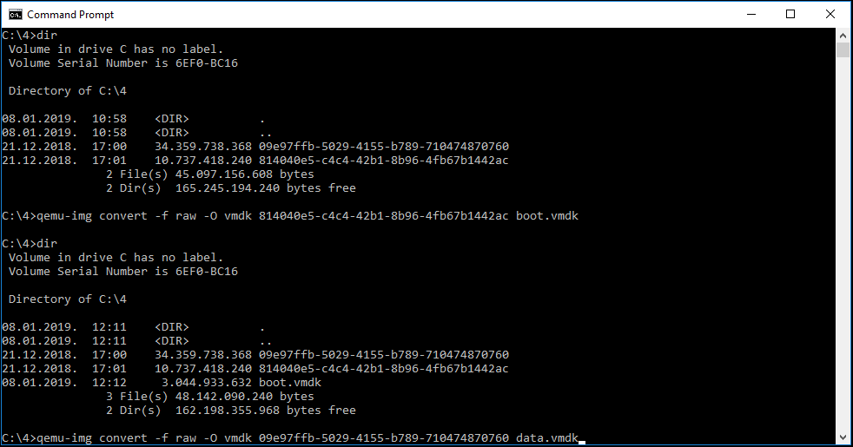
STEP 1 (Create new VM in VM Player and customize it) video file
- Select Create New Virtual Machine
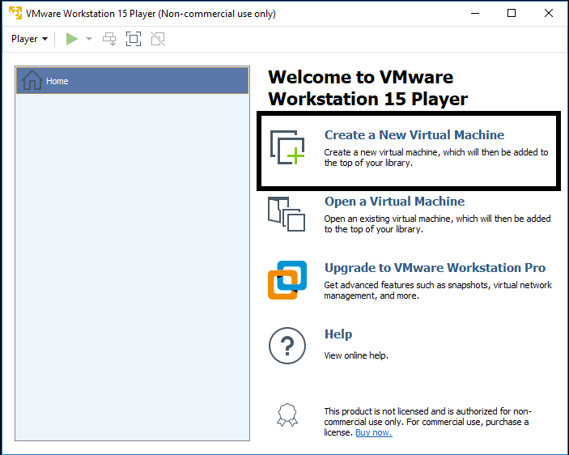
- On next screen select I will install operating system later
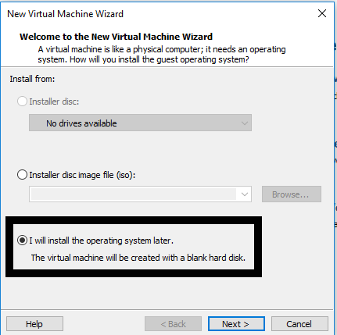

- On next screen select Linux on top and Version CentOS 7 64-bit
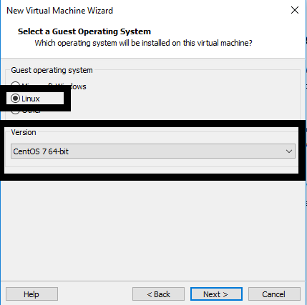
- Enter VM name and select location on local computer where VM will be stored
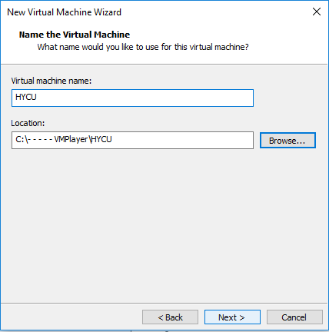

- Enter size of VM boot disk to be 10 GB and select Store Virtual disk as single file
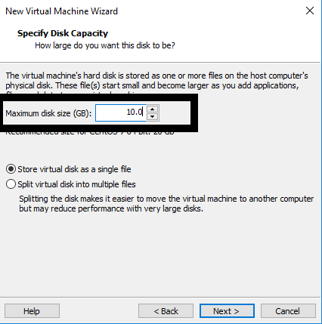
- On next screen click on finish
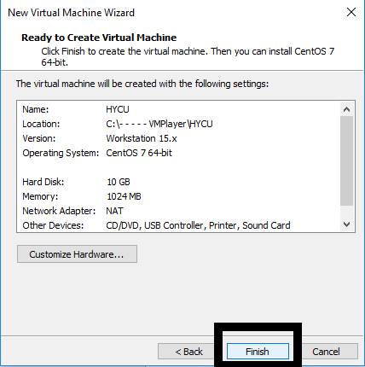

- Copy converted files to folder where your new VM is created
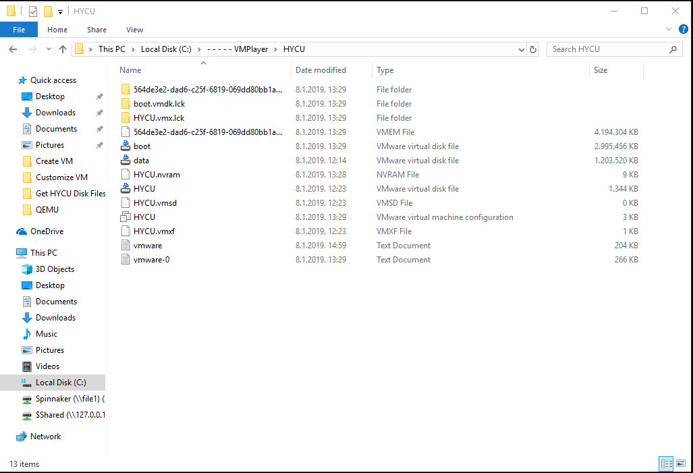
- Edit .vmx file with text editor .vmx file is located in folder where you created new VM (change line scsi0:0.fileName = "HYCU.vmdk" to scsi0:0.fileName = "boot.vmdk")
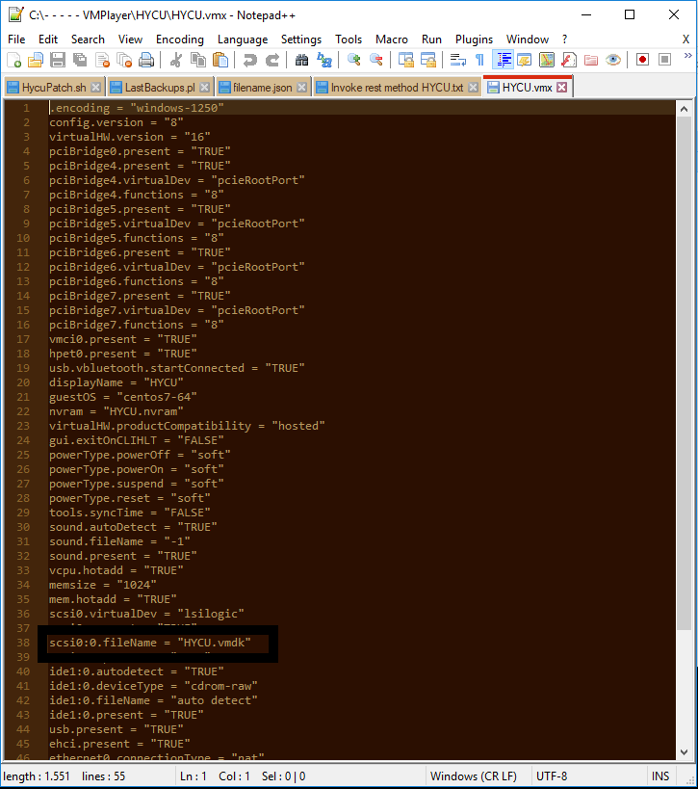

- Save File
- Open VM player, select VM and Select Edit virtual machine settings
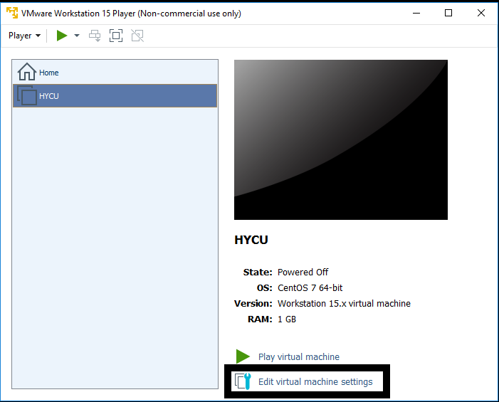
- Edit memory settings to 4 gb
- Edit Processors to 2 cores
- Remove CD drive
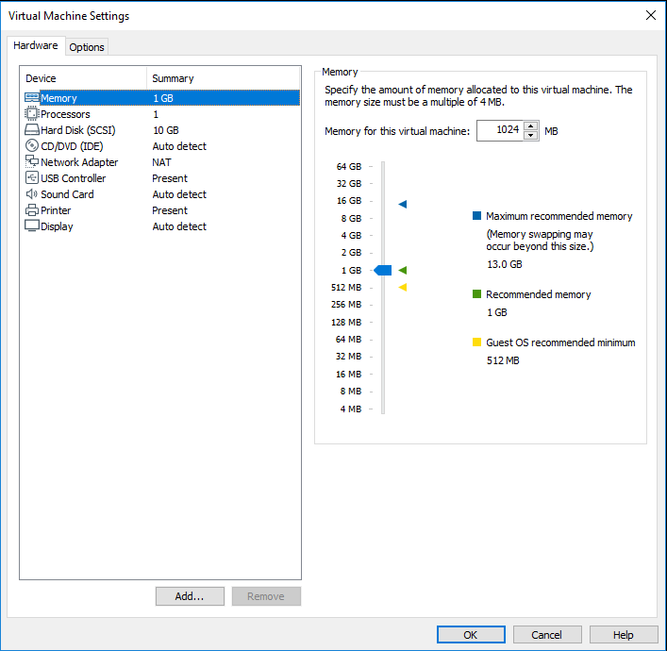

- Add another HDD, select SCSI hdd drive select use existing virtual disk, browse for data hdd file, click on finish and click on keep existing format
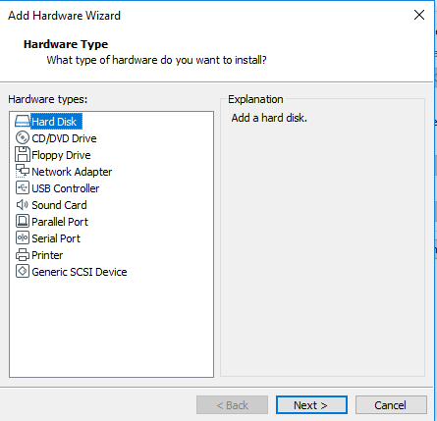
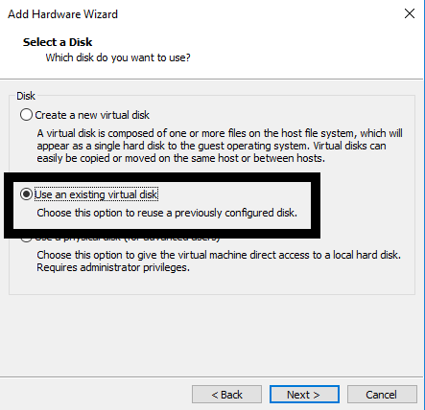
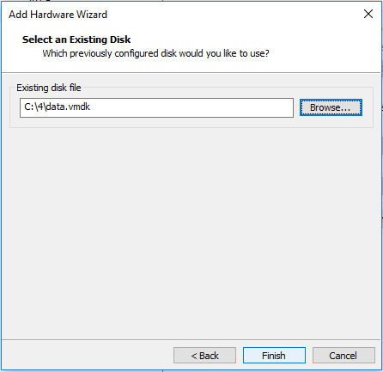
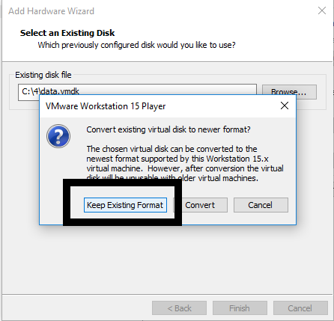
- On network controller select Nat
- Save VM settings
- Run VM
- When controller is up, login with credentials hycu / hucu/4u use command sudo nmtui to access network settings of controller, you will be asked to enter password one more time so enter hycu/4u
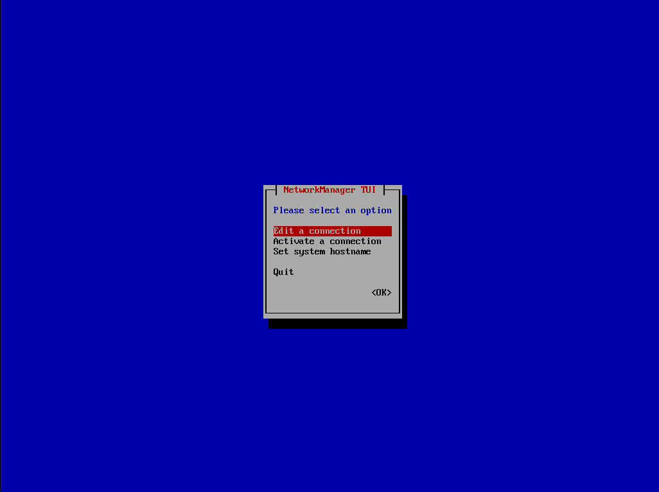
- Select Edit a connection
- Select Wired connection 1 and delete it
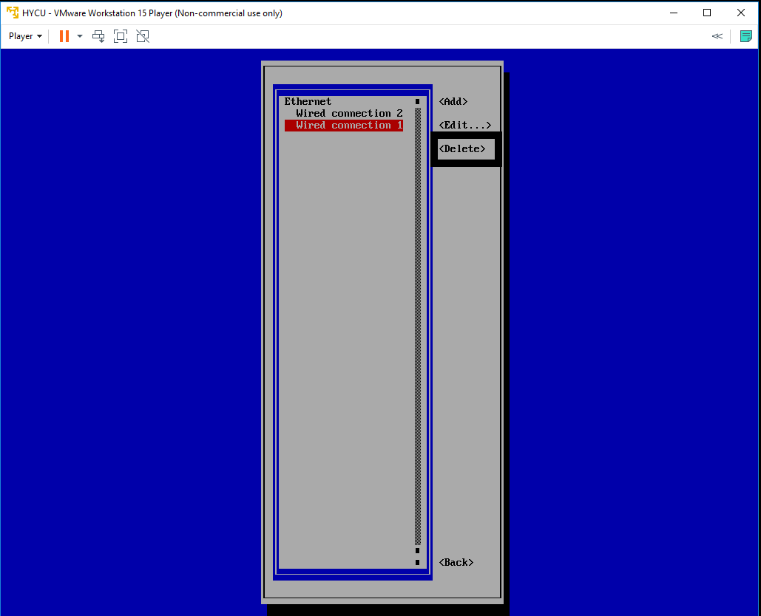

- Select Wired connection 2 and Edit it, change name to Wired connection 1
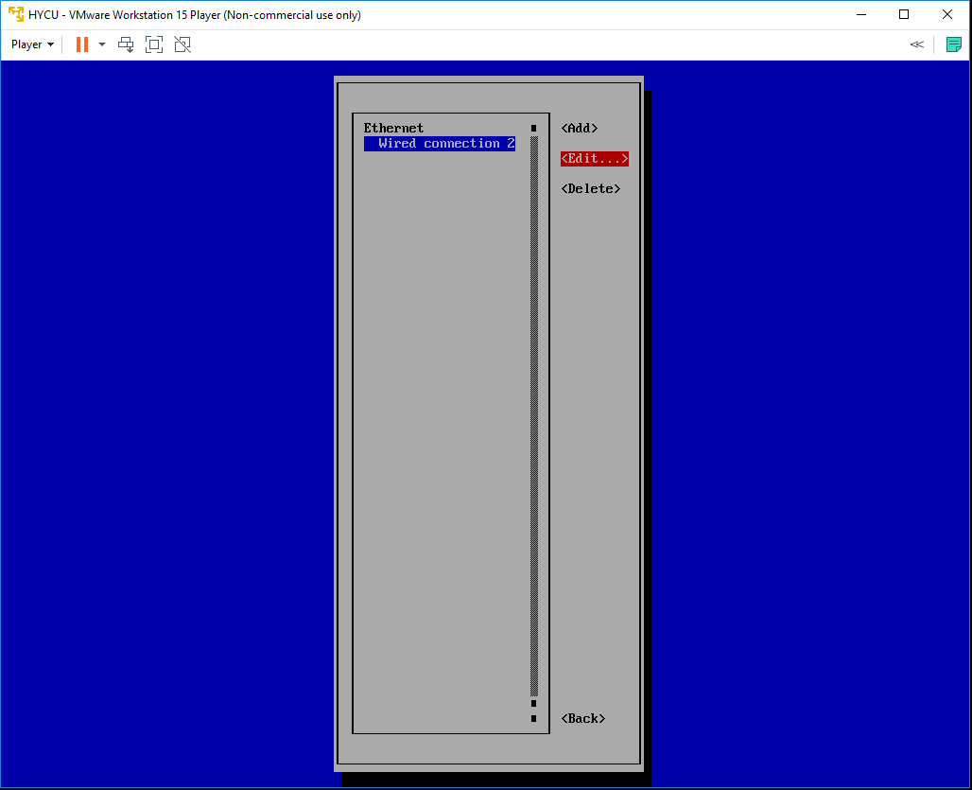
- Quit nmtui and reboot controller sudo shutdown –r now
- Login to console with same credentials and run ifconfig command to get controllers IP address
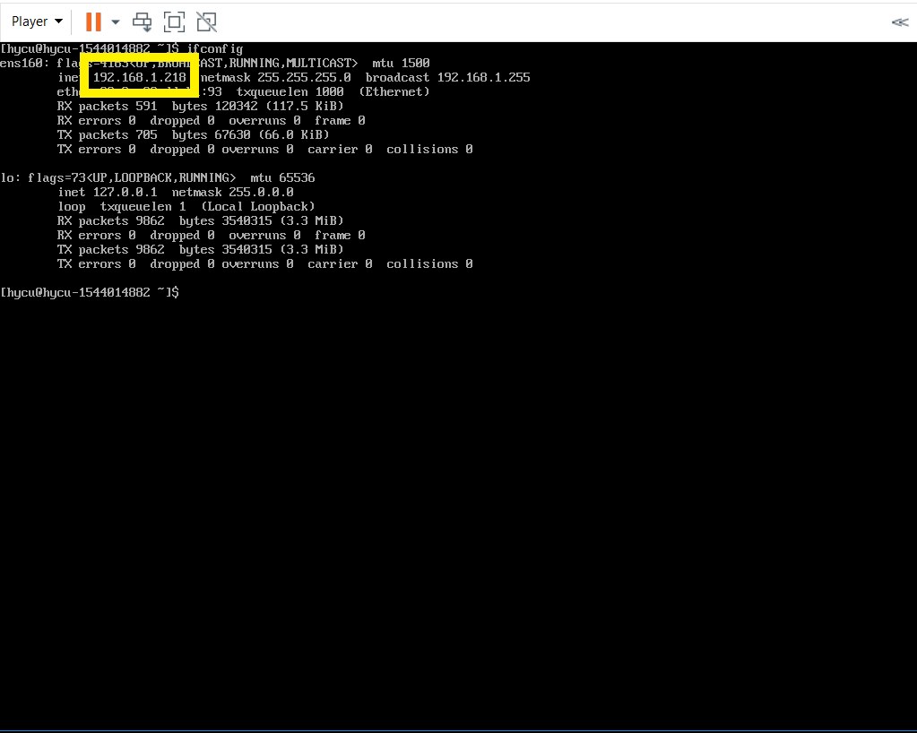
- Use that address to access HYCU GUI
STEP 2 (Restore VM Virtual Disk Files and convert them if needed) video file
- Navigate to Virtual Machines tab on left
- VMs that have backup will be shown as PROTECTED_DELETED since source is not available
- Select VM and select Restore VM or vDisks
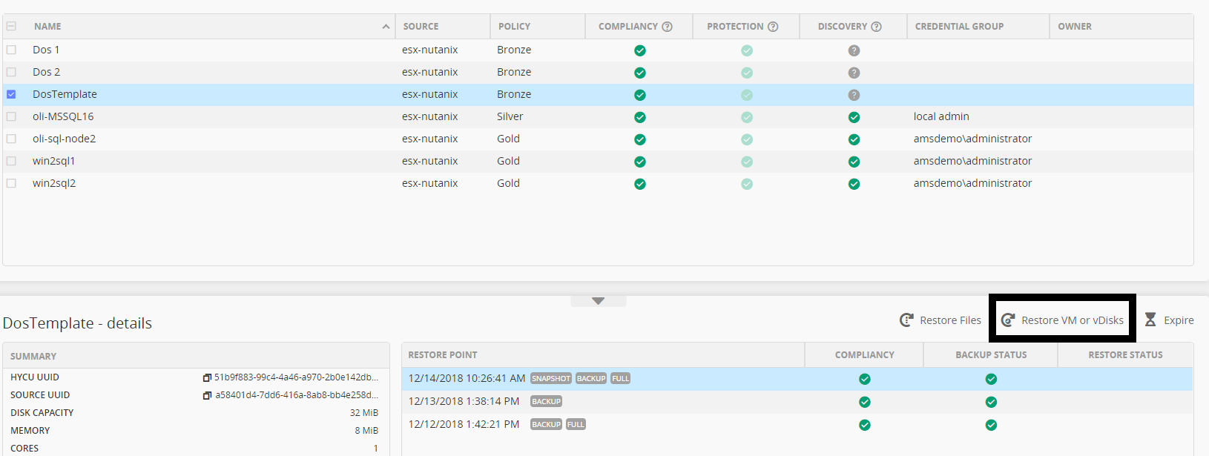

- New form will be shown. Disregard warning.
- Select Export vDisks
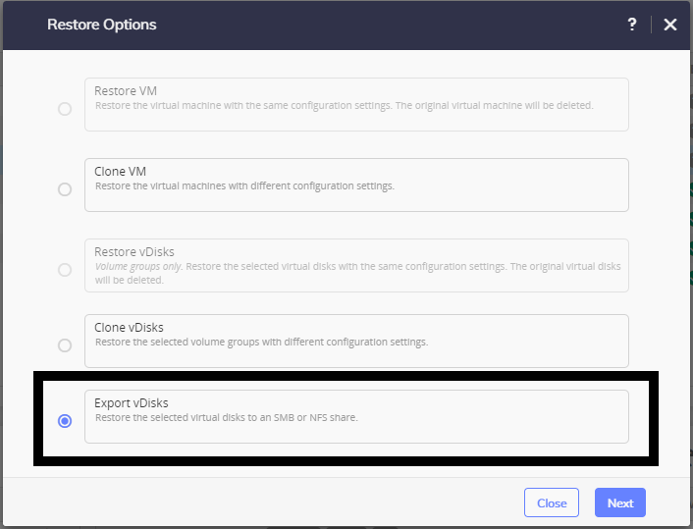
- Select vDisk that you want to export
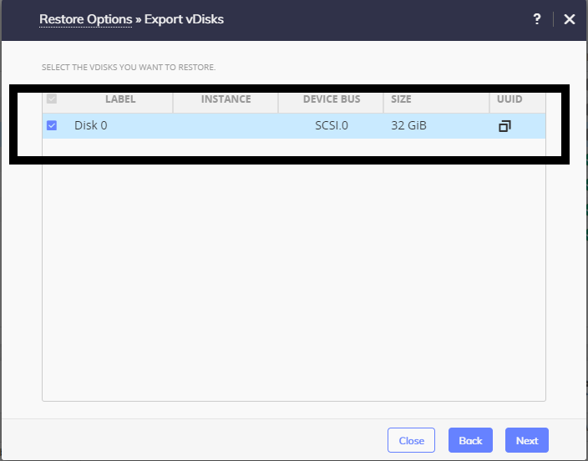
- Enter Share Data
For SMB
- Domain, Username and Password are optional if exists
- Enter SMB server DNS name or IP address
- Enter Shared Folder name in format /<FolderName>
- Choose Restore Instance (recommended is AUTOMATIC)
For NFS
- Enter NFS server DNS name or IP address
- Enter Shared Folder name in format /<FolderName>
- Choose Restore Instance (recommended is AUTOMATIC)
- Select Restore
- When restore job is completed, you should have something like this in shared folders. If you have multiply disk exported you will have multiply *.vmdk files in folder
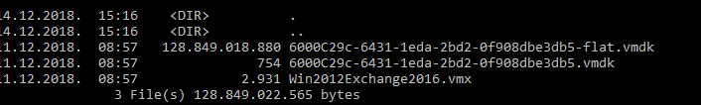
STEP 3 (Install Azure Powershell module and covert image to vhd) video file
- Open Powershell as administrator on your local machine and enter command Install-Module –name AzureRM –AllowClobber
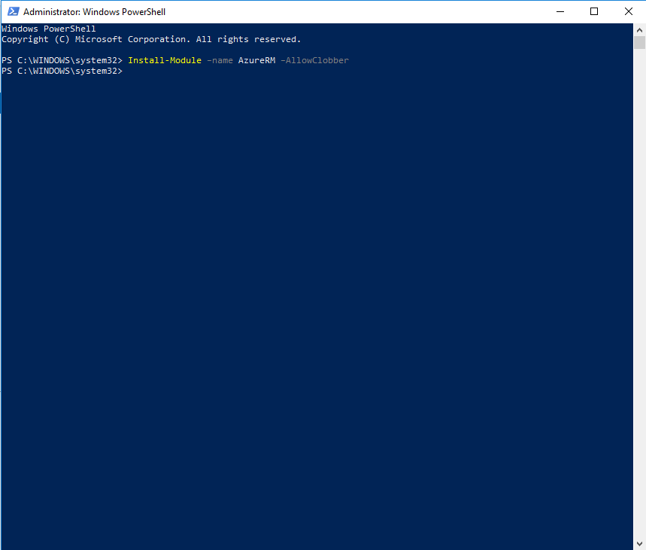
- Before upload of hdd image to Azure images need to be converted to fixed size VHD hdd images, navigate to the folder where your exported image is located.
- Convert image with command qemu-img convert -f <type of source image> -o subformat=fixed,force_size -O vpc <name of source image file> <name of image for upload>.vhd

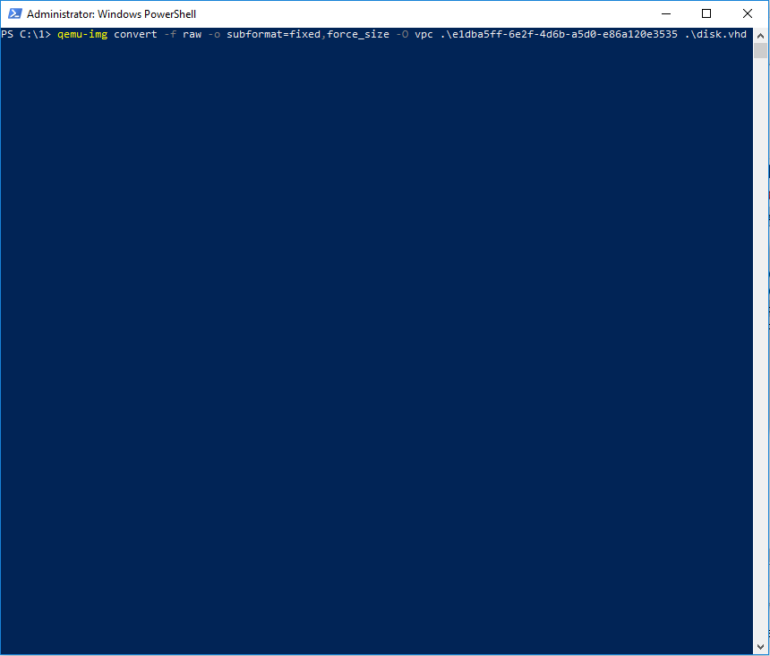

STEP 4: (Configure Azure for deployment) video file

- When conversion done login to your Azure compute account
NOTE: You will need administrator privileges on Azure

- Select portal on top
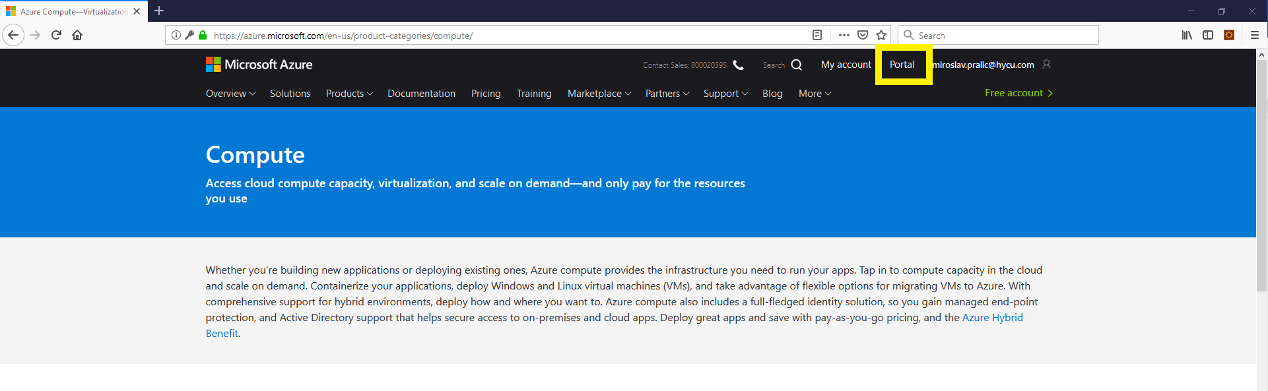
- On portal you need to create a resource group, navigate to resource group on left panel
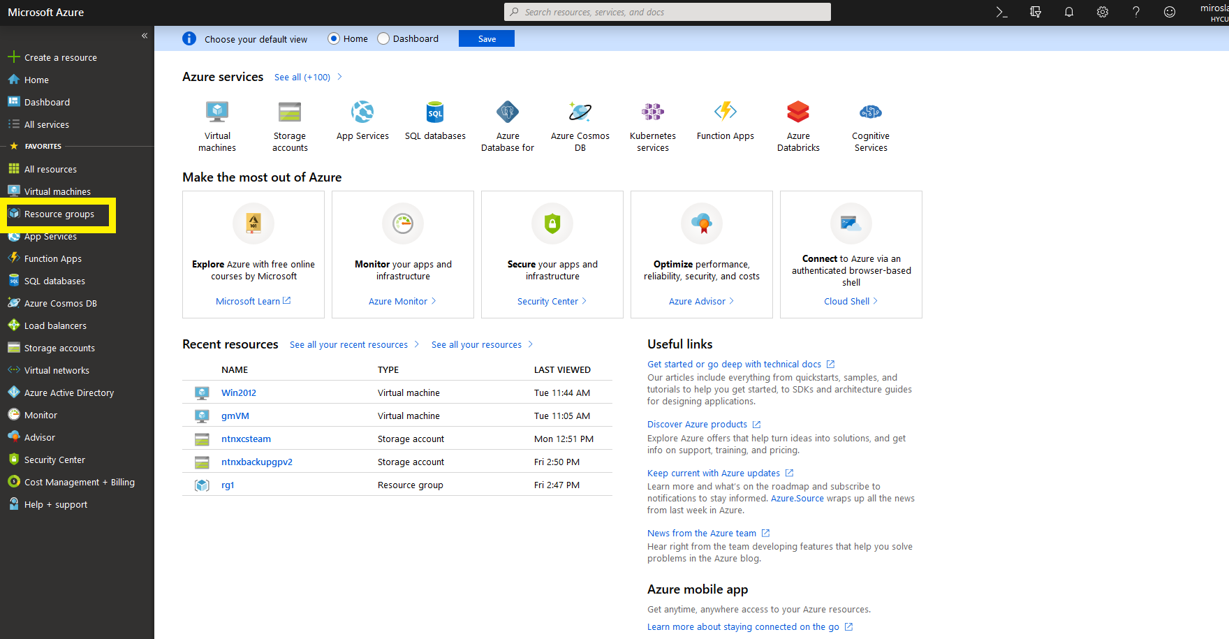
- Create new Resource group, click on Add button
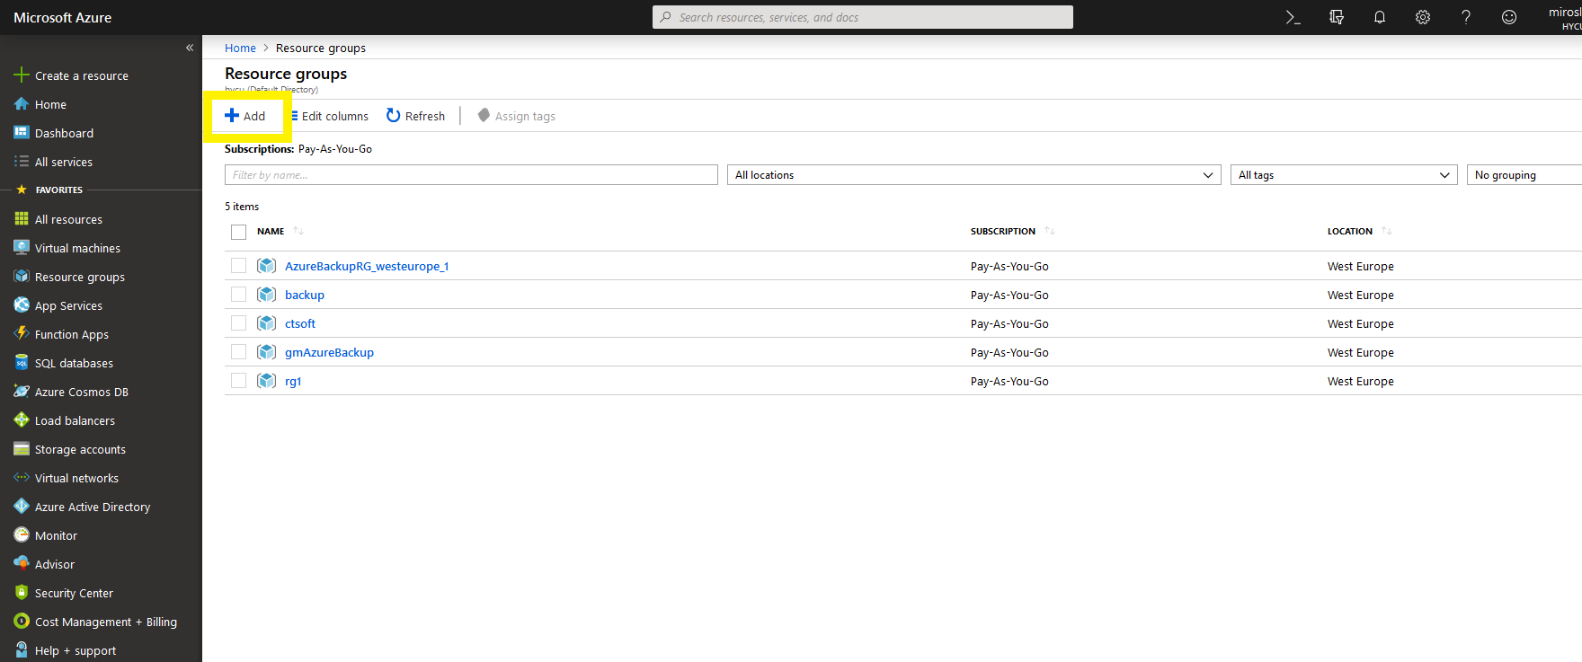

- Select your subscription model, enter group name and select your region
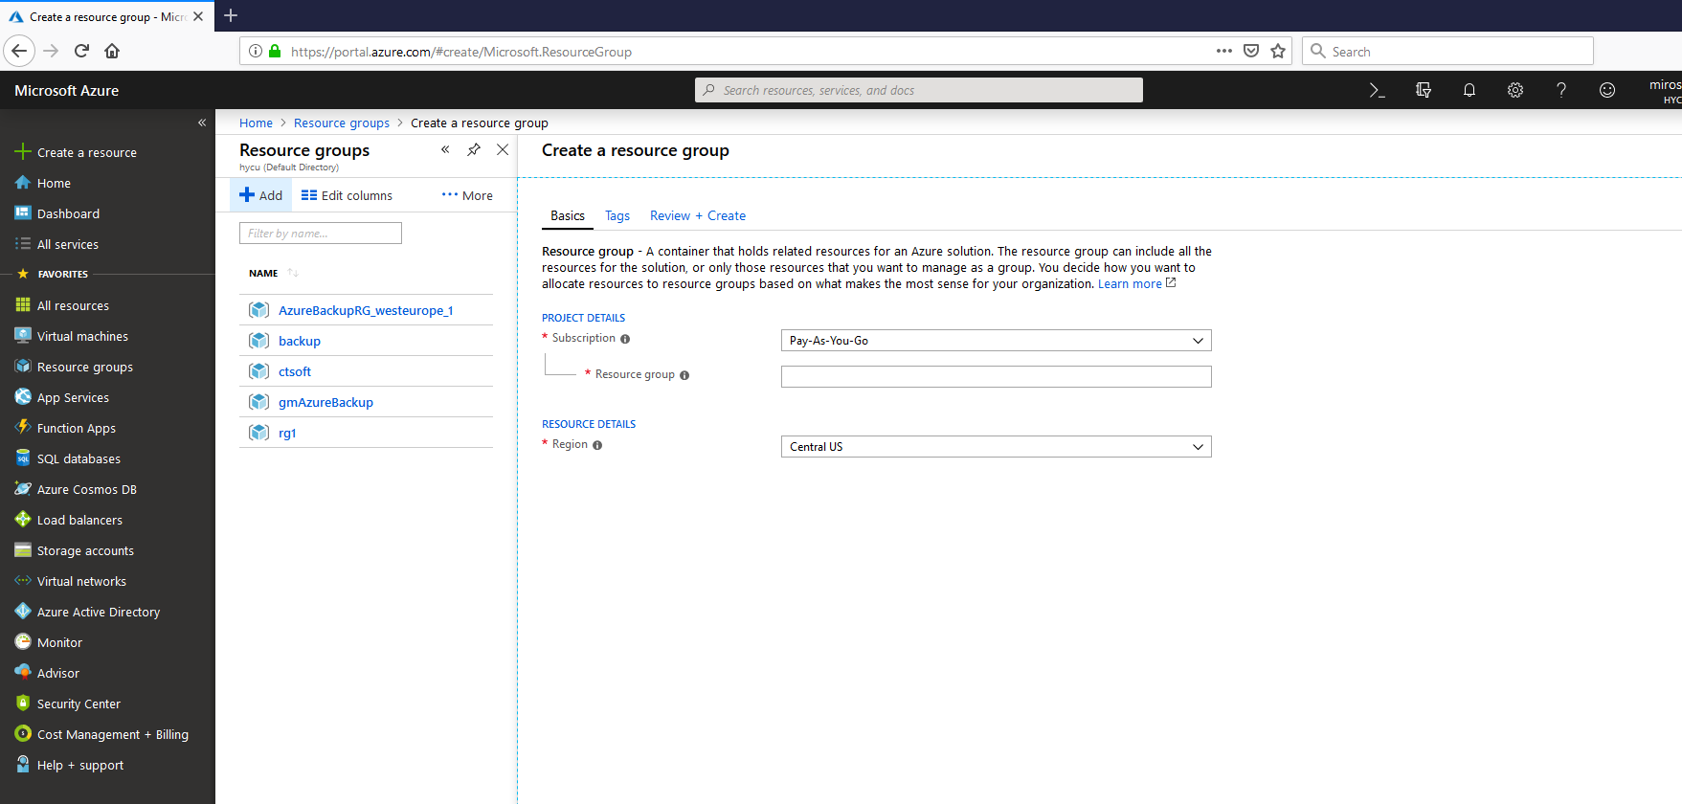
- Click on Review+Create button on bottom, and once again to Create button
- Select Storage Account on left menu
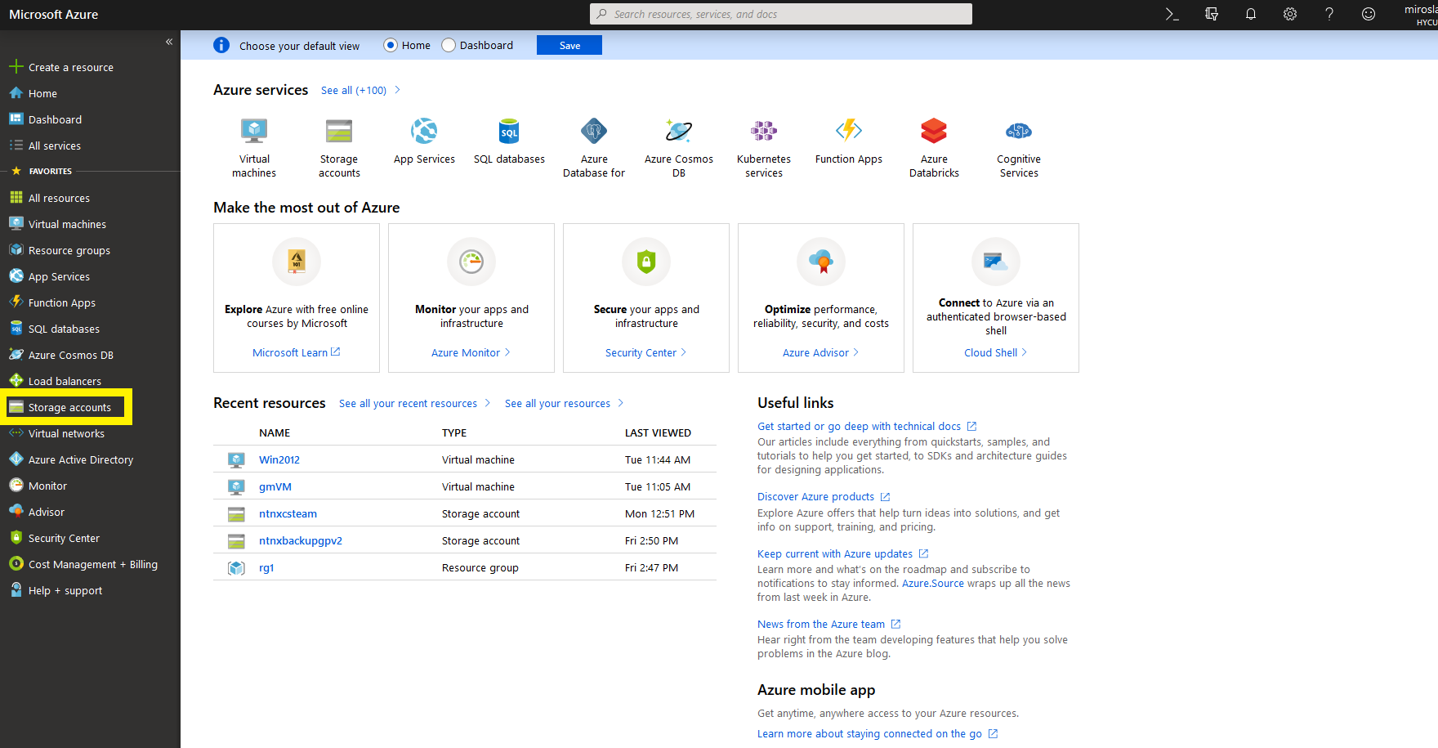
- Add new Storage account

- Select your subscription model, choose resource group that you just created, enter account name, select location, performance, for Account kind select StorageV2 and for access tier Hot.
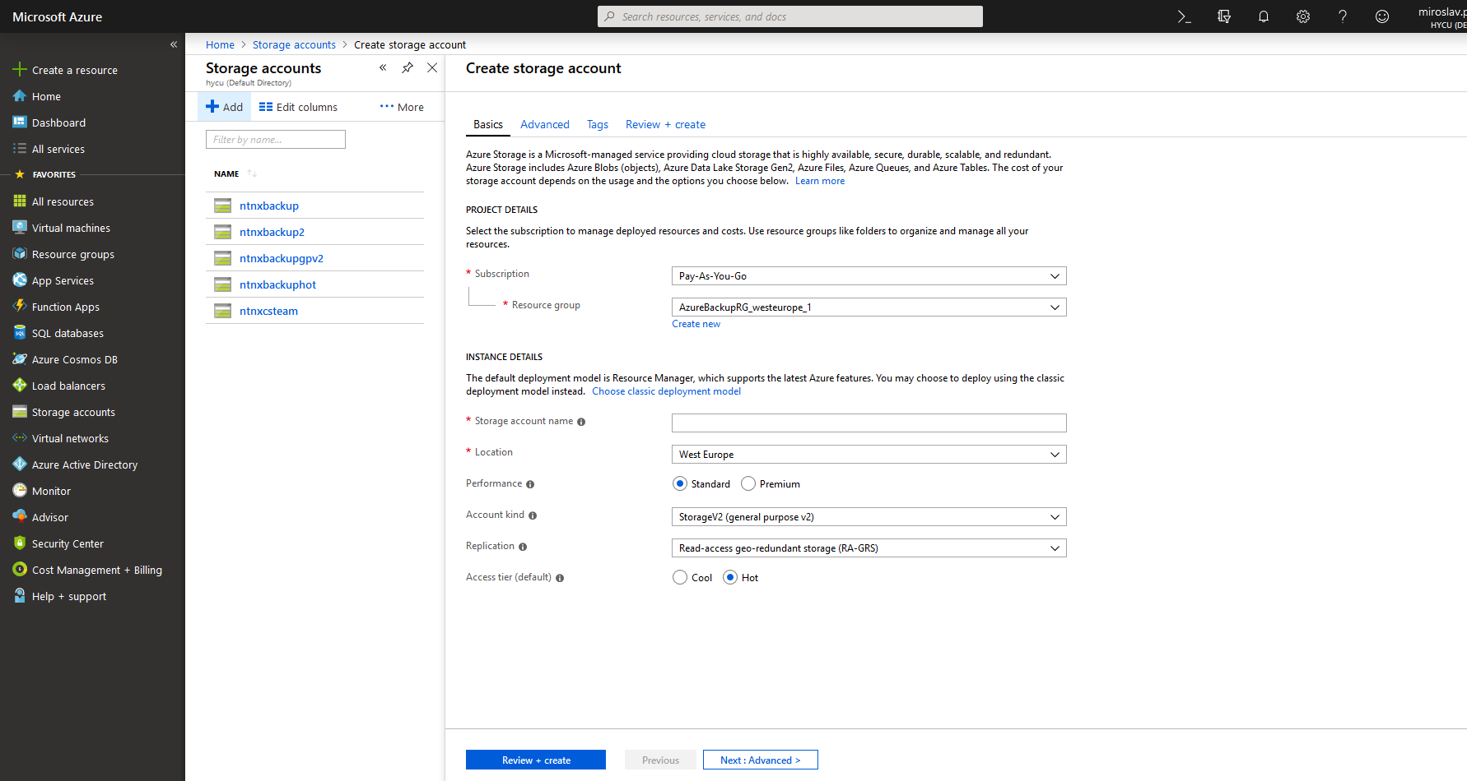
- Click on Review + Create and confirm Create
- Select Storage account on left menu again
- Click on account that you just created
- Select Blobs
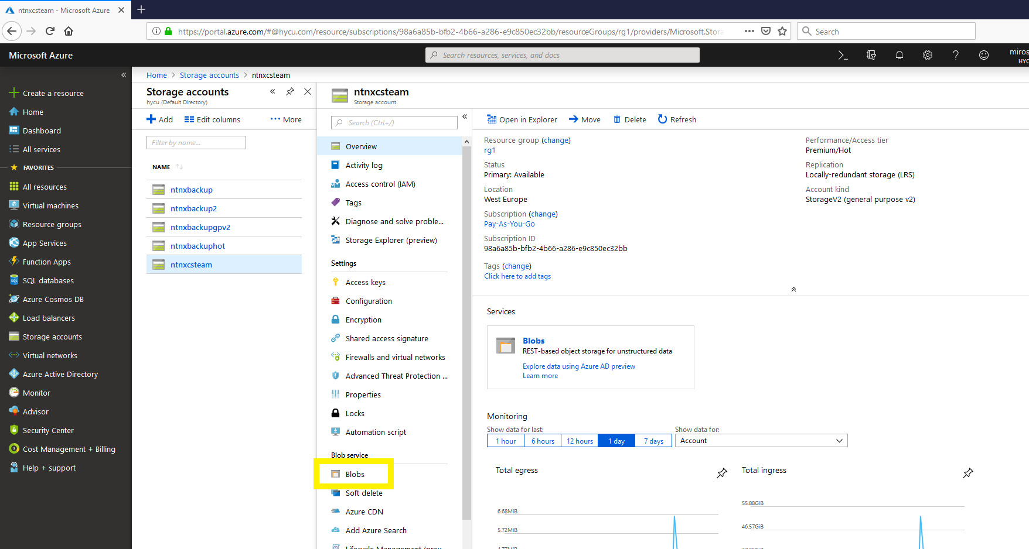
- Add new Container

- Select new container that you created, click on Properties on left menu
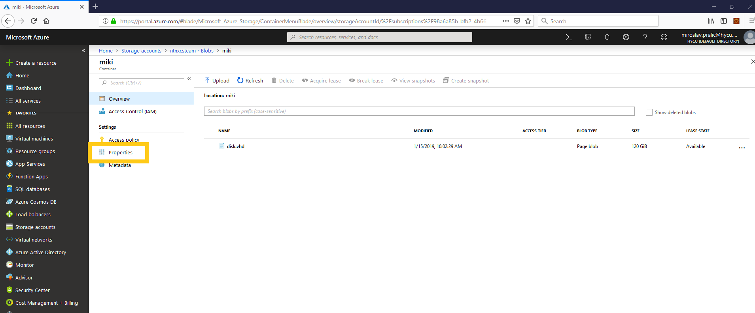
- Get value from URL field, it should be https://<storage account name>.blob.core.windows.net/<blob name>
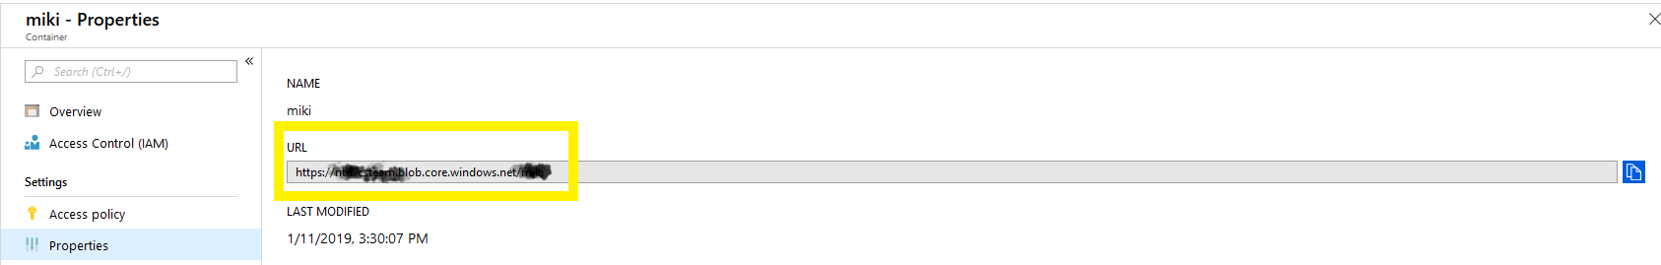

STEP 5: (Upload image to Azure and convert it to Azure Rm image) video file
- Run Powershell as administrator, navigate to the folder where your converted hdd image is
- Connect Powershell with your account use command Connect-AzureRmAccount
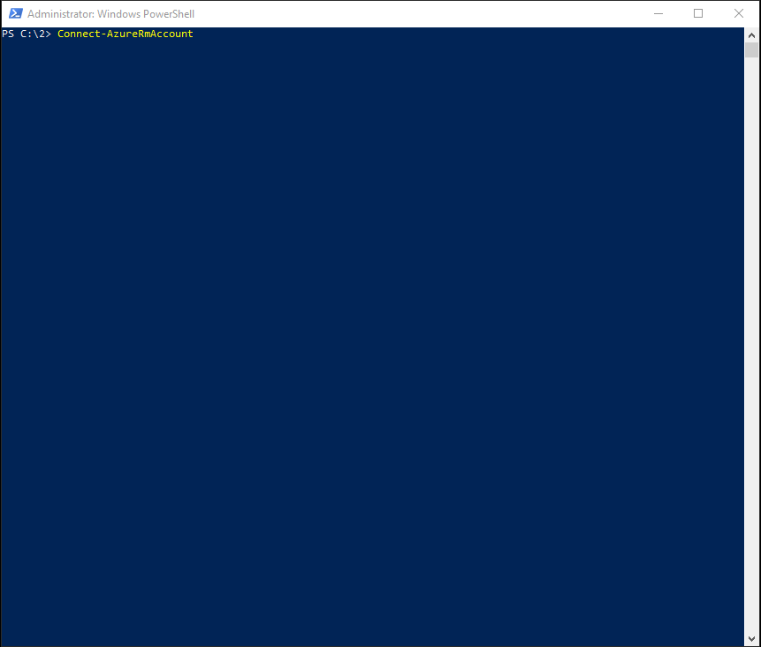
- On new window enter Azure account user name
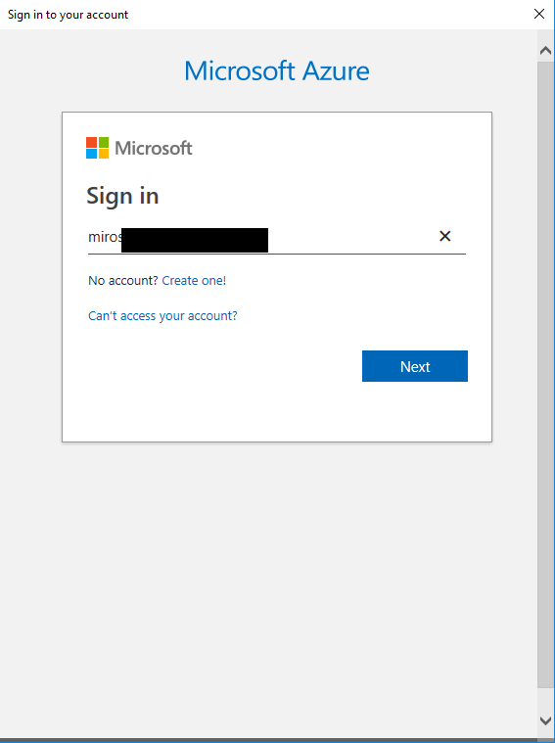
- On next screen enter password

- On successful connect you will see this
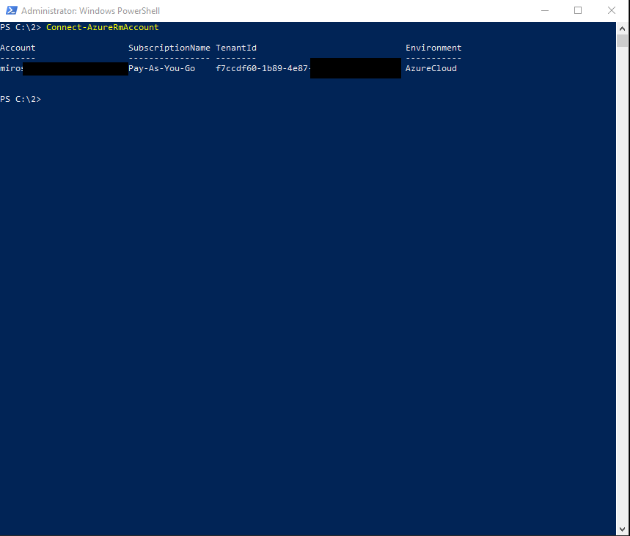

- Now variables need to created, enter following lines to Powershell window
- $rgname = “<Resource group name that you created> “
- $uploadURL = “<url that you get from blob properties>/<name of disk file>.vhd”
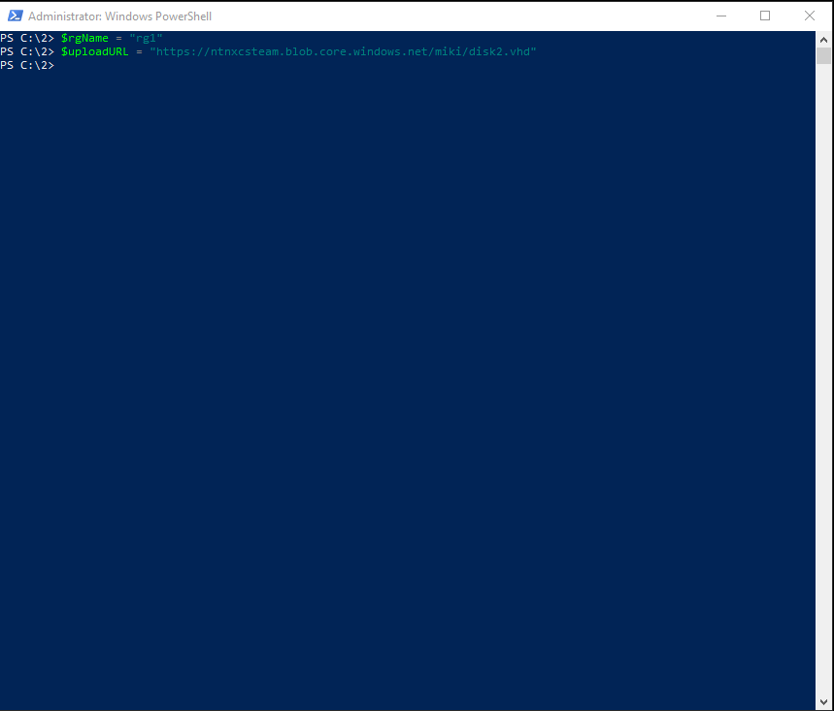
- Use following command to upload VM hdd image to Azure Add-AzureRmVhd -ResourceGroupName $rgName -Destination $uploadURL -LocalFilePath "<absolute path> \<image name>.vhd
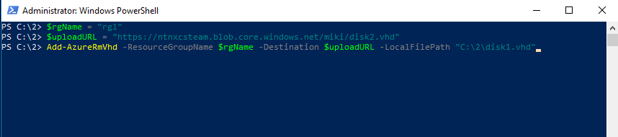
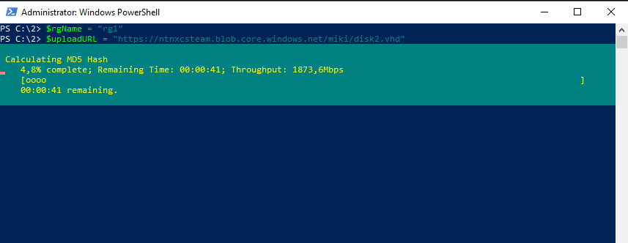
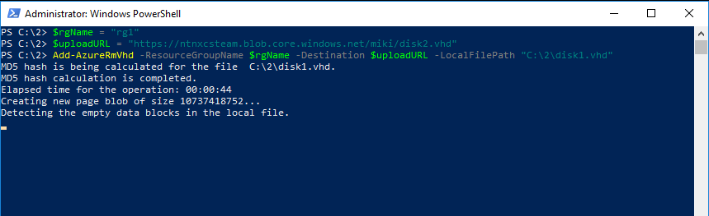

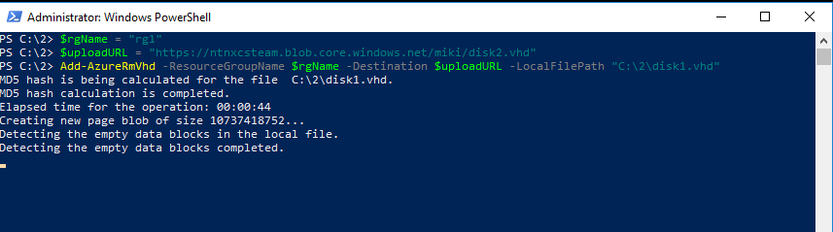
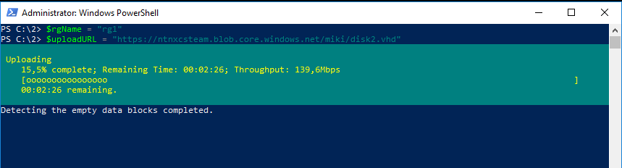
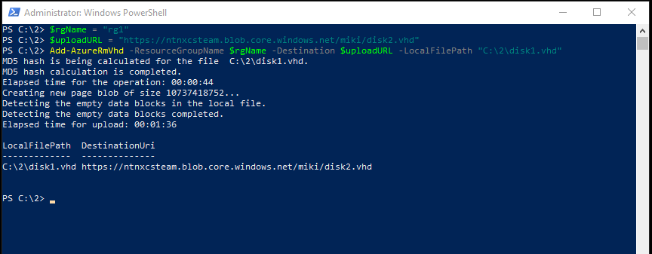
- New Variables need to be created, execute following commands
- $location = “<Location of your blob>”
- $imageName = <Name that you will give to new image that will be created>
- Create the image using your VM VHD, use following commands
- $imageConfig = New-AzureRmImageConfig –Location $location
- $imageConfig = Set-AzureRmImageOsDisk –Image $imageConfig –OsType <VM os Type> -OsState Generalized –BlobUri $uploadURL –DiskSizeGB <example 120 (size of uploaded disk)>
- New-AzureRmImage -ImageName $imageName -ResourceGroupName $rgName -Image $imageConfig
If everything is done successfully you will see this messege
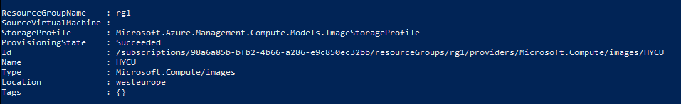

STEP 6: (Deploy Image as VM) video file
- Close power shell and return to Azure portal, on portal Select Virtual networks on Left
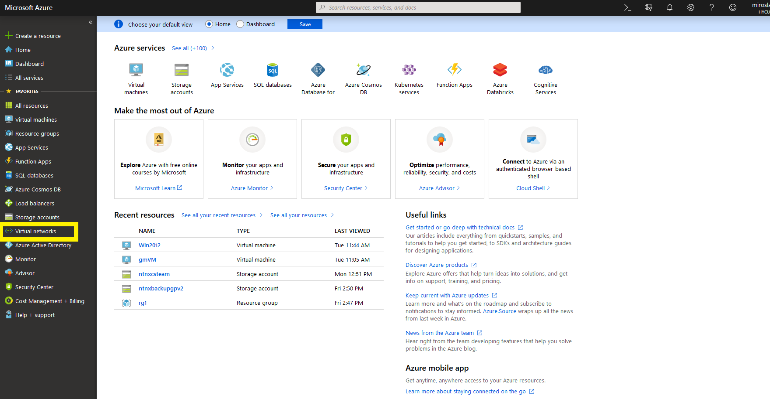
- Click on Add
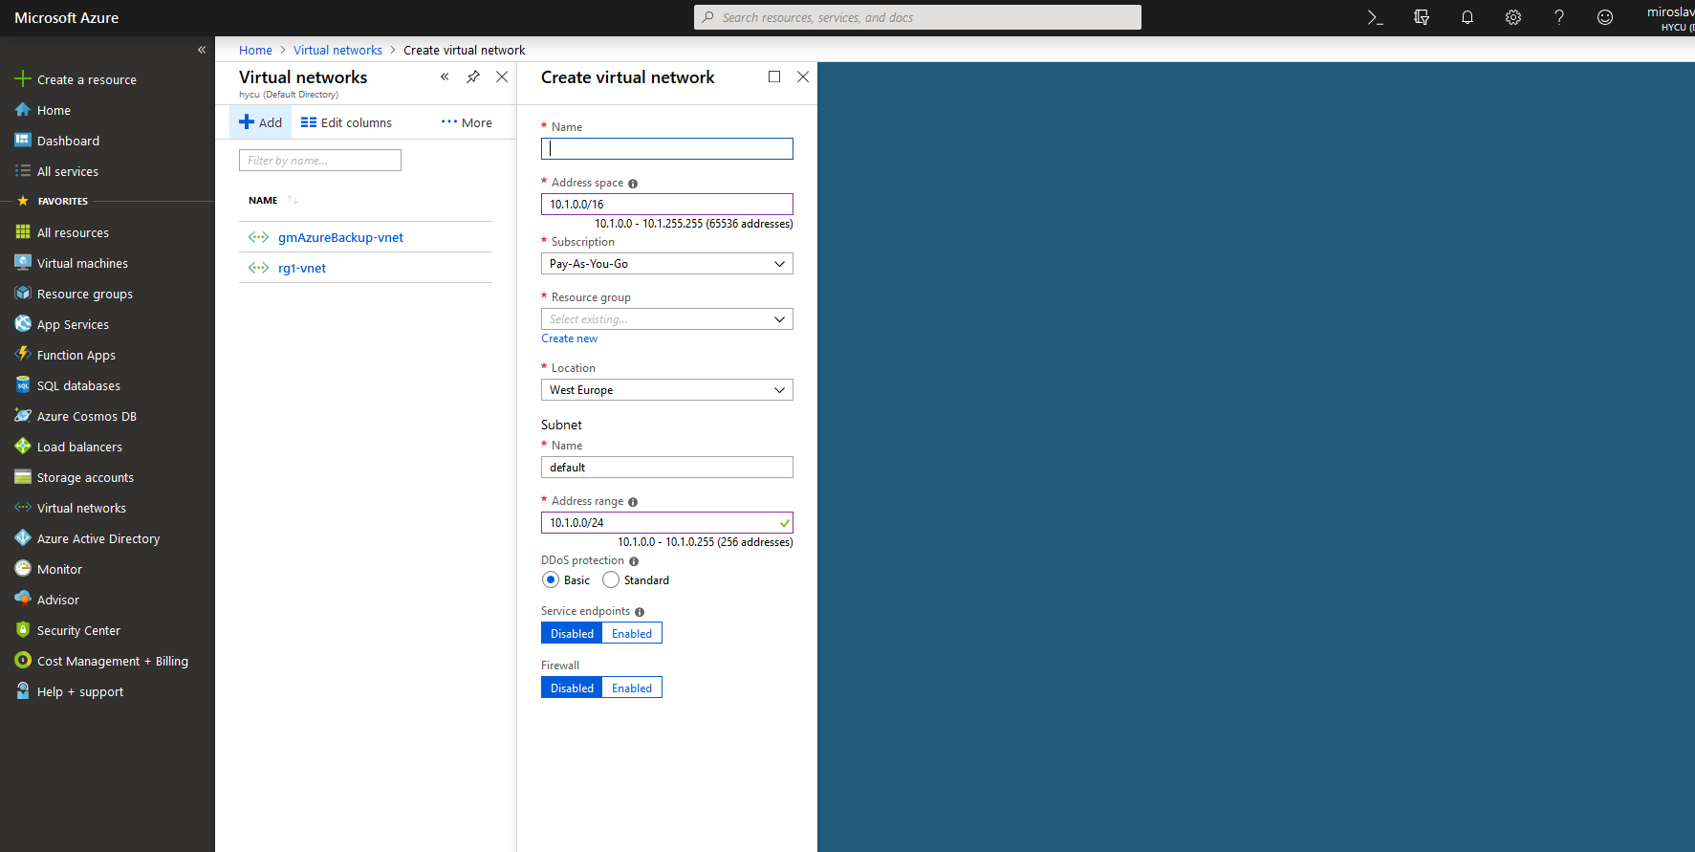
- Enter name, select Address space, select Subscription, choose Resource group that you created, select location, enter name for subnet and select Address range and click on create
- Select Virtual machine on left
- Click on add and select Subscription, select resource group that you created, enter VM name, select Region to match location that you selected, select Availability options if needed
- Click on Browse all images
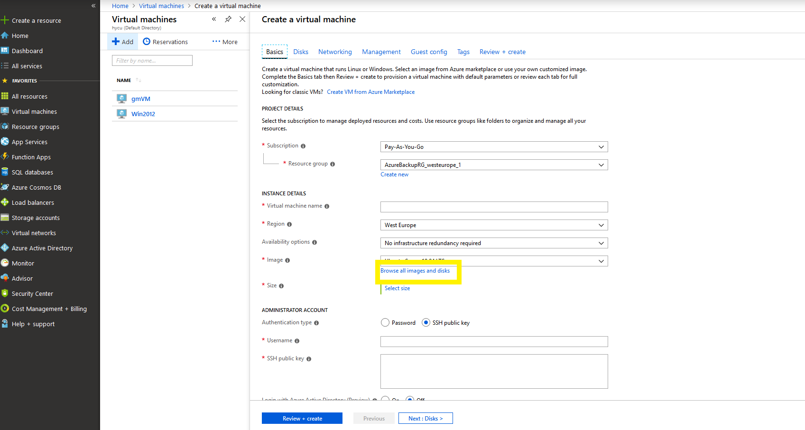
- Select My Items
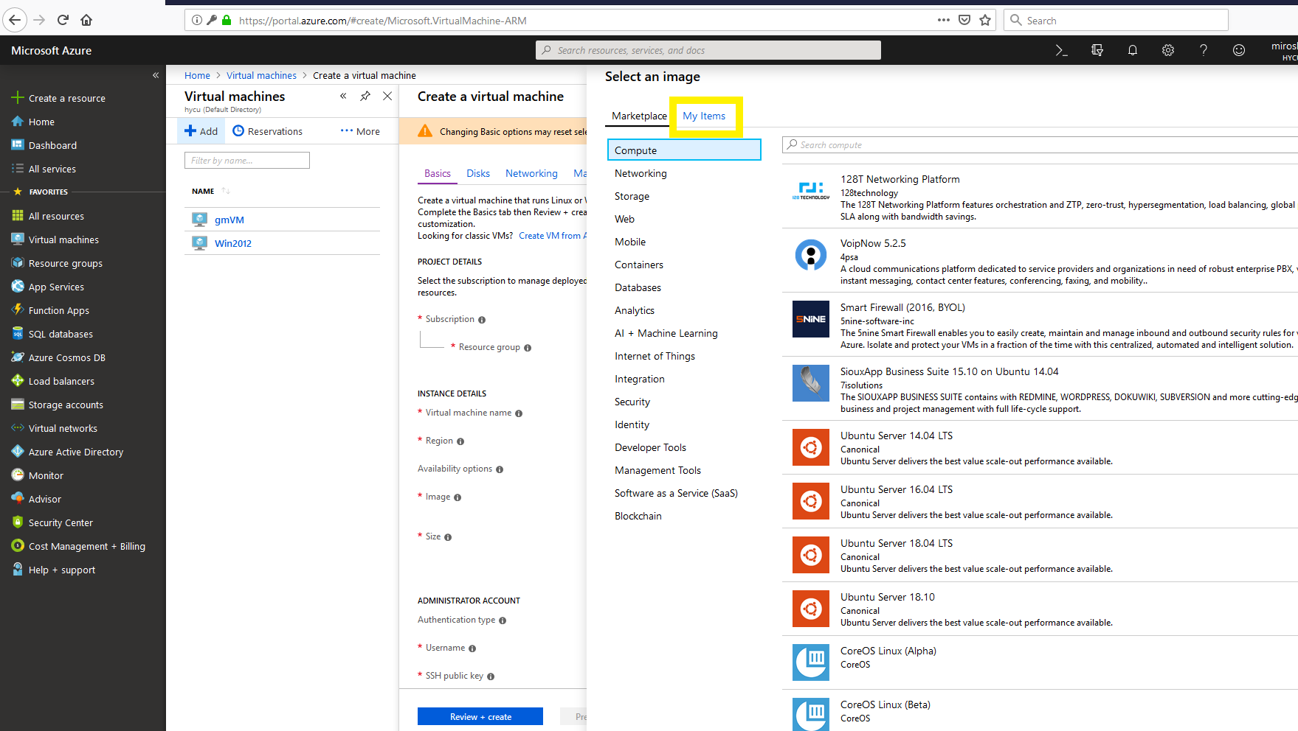
- Select image that you created
- Adjust size of your VM, select authentication type to password, enter username and password NOTE: username need to be 20 characters max, select public inbound ports, for windows VM pass through RDP port. Click on Review and Create
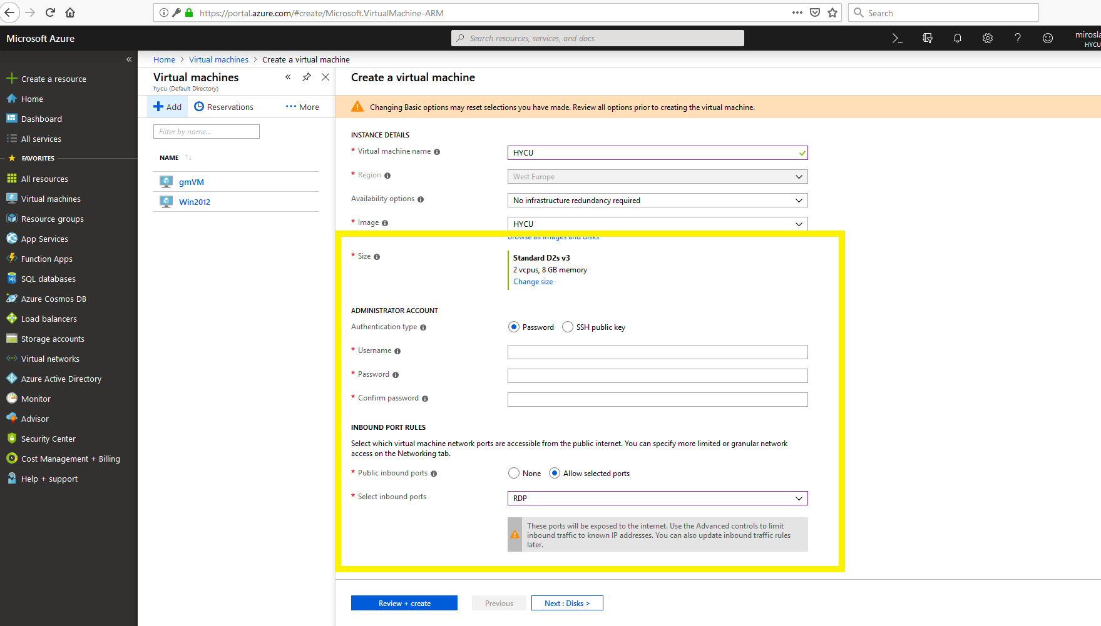
- If validation passed click on Create. Creation process will take some time. After process is donego to Virtual machines on left, select VM that you created, and press start to run it.
- To access VM click on connect and choose RDP or SSH access to VM

